

**Day 8 :**

**Topic :**Introduction about visual studio editor and attach the college management application

**Milestones / Activities :**

Visual studio editor introduction and tools and chrome console command in javascript

**Detailed Description :**

**How To Use Visual Studio Code:**

Install Extensions in Visual Studio Code.

1. Salesforce CLI Integration
2. Salesforce Extension pack

Salesforce Extension pack consists of several extensions, all of which are published by Salesforce. The extension pack has the following extensions, as of now, which will be activated automatically when you install this pack.

**The Salesforce CLI Integration Extension Pack**

* Apex
* Visualforce
* Aura Components
* Apex Interactive Debugger
* Apex Replay Debugger
* Lightning Web Components

**College management application accesing in the visual studio**: To add files and access to the visual studio.



The application form and colleges and all you can access onto it.

In the visual studio code in left bar you can show the file names with college management application. In this you can access the apex classes and apex trigger codes.

**Lightning web components :**

Lightning Web Components (LWC) is a stack of modern lightweight frameworks built on the latest web standards. It is a DOM (Document Object Model), element created through reusable code and is used to generate a dynamic interface without using JavaScript or building a Library. This feasibility makes it quick and seamless, saving the developers a ton of time and effort on the Web Stack. Let’s look at some of its remarkable features:

* Improved performance of the component as most of the code is recognized by the native web browser engine and web stack
* Ability to compose applications using smaller chunks of code since the crucial elements that are required to create a component is part of the native web browser engine and web stack
* Increase in the robustness of the applications built using LWCs as they are inclusive of the said modern web standards.
* Parallel interoperability and feasibility to use both Lightning Web Components and Aura components together in the applications with no visible differentiation to the end-users

Uses of the lightning web components :

If your organization is already using Aura-based lightning components and the development team is highly skilled with the Aura framework, here’s the good news — the Aura Framework is not going anywhere. However, LWCs are the future of lightning development.



**Screenshots of Milestones / Activities :**

In visual studio to download the salesforce extension pack :

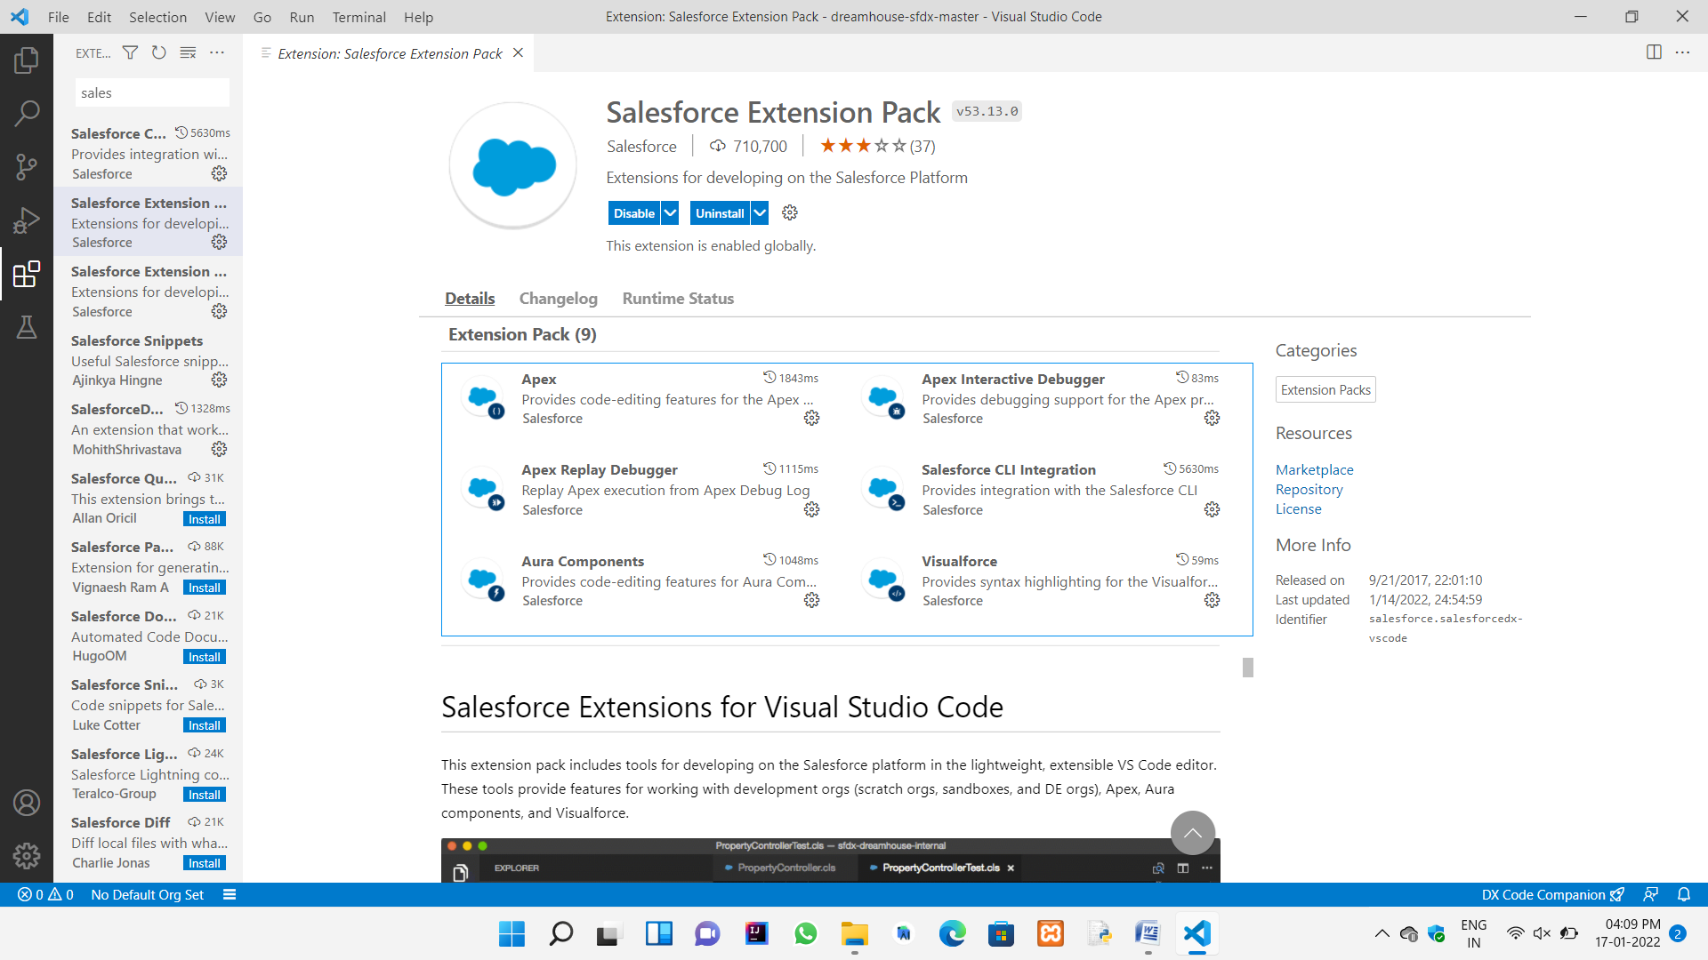



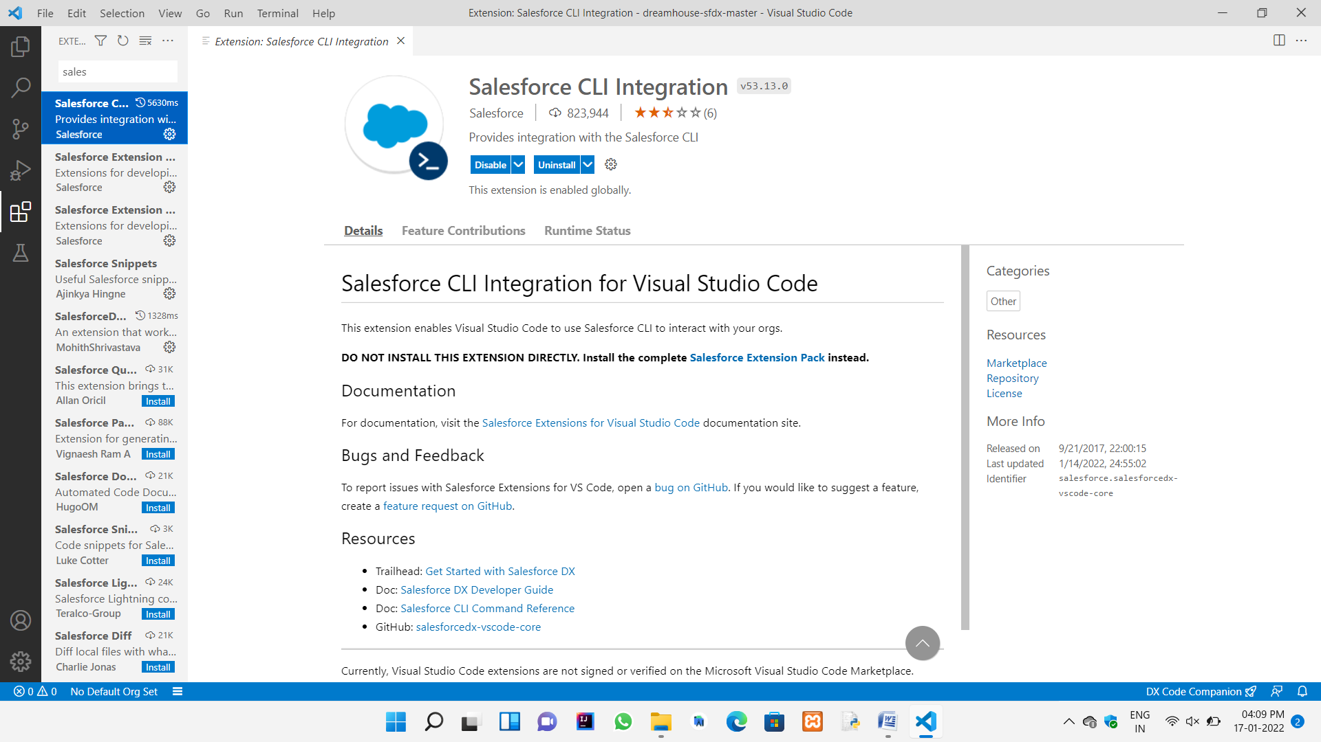

Connect the organization to the visual studio :



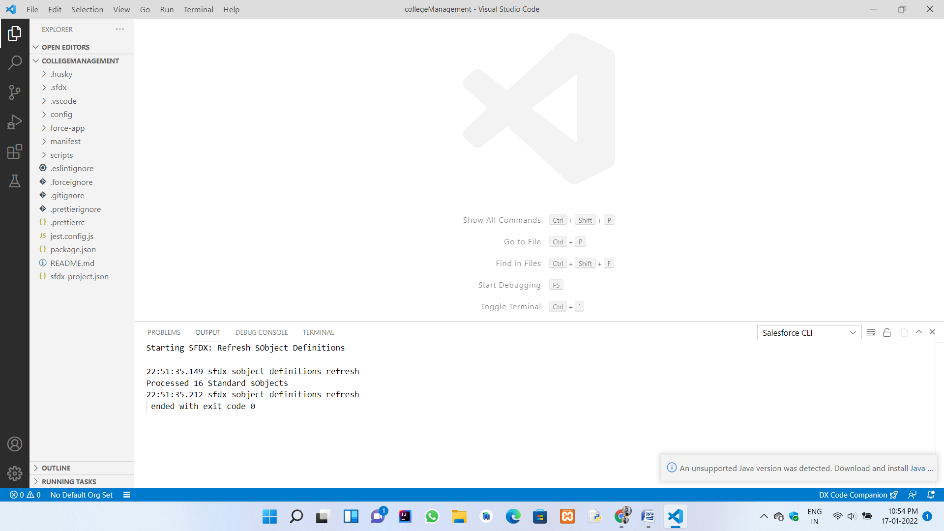

Extensions of the chrome :



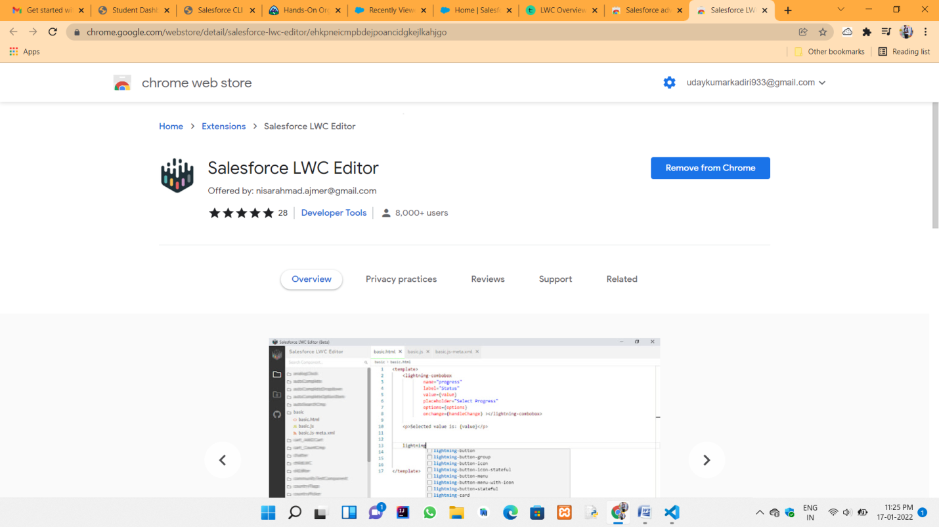

Javascript functions to run in the console in the chrome browser :



